**Research Strategy**

*Summary of parent grant (2R01DC007703) Specific Aims*

Ensemble taste responses of primary gustatory cortical (GC) neurons evolve through 3 distinct firing rate “states” across the 1-1.5 seconds following stimulus delivery. It is unlikely that GC generates such nonlinear dynamics independently, however—such complexity of ensemble activity almost necessarily emerges from interactions between multiple brain regions. To truly understand this system, we must understand the functionality of coupling between GC and other brain regions. The parent grant pursues such an understanding, using multi-site electrophysiology, optogenetic silencing, and advanced analysis of neural ensemble activity and behavior, to test hypotheses regarding how GC works with three other brain regions:

**Aim 1**. Investigating amygdala-cortical and cortico-amygdalar pathways. We are testing the basic hypothesis that an intact loop connecting BLA and GC is vital for normal coherent dynamics of GC responses. We prepare rats such that illumination of GC perturbs activity in BLA◊GC axons (without altering somatic function in BLA or GC), and specifically test whether this perturbation changes GC taste response dynamics; in parallel experiments, we instead perturb GC◊BLA axons. Finally, we are performing dual-site ensemble recording to test the specific hypothesis that GC-BLA coupling centers on moments of “state transitions.”

**Aim 2**. Investigating hypothalamo-cortical and cortico-hypothalamic pathways. We are performing experiments analogous to those described for Aim 1 in order to evaluate the role LH-GC connectivity plays in taste, hunger, and thirst, and to test the degree to which any LH◊GC influence is mediated by BLA. We are extending this work to examine whether LH’s coupling with GC is cell-type specific, perturbing inputs to GC from genetically identified subsets of LH neurons.

**Aim 3**. Investigating pathways from GC to the reticular formation (RF) central pattern generator (CPG) for orofacial movements. On the basis of recent work from our lab, we hypothesize that a specific “state transition” in GC taste responses acts to modulate activity in the multi-functional RF CPG responsible for oral rhythms. We are perturbing activity in GC◊CPG axons, and testing the specific hypothesis that this perturbation, delivered at the time of GC state transitions, hinders the onset of consumption behavior without affecting forebrain dynamics.

*Aims of the proposed supplement, and its connection to the parent grant*

While I already have students performing experiments in service of each of the 3 Aims described above, the research activities proposed for this supplement relate directly to Aims 1 & 2. The precise logic unpacked in the parent grant to motivate investigation of GC’s connections to BLA and LH is doubly relevant to an investigation of the coupling between GC and piriform (olfactory) cortex (PC), as are the tools used to do so: not only is the olfactory system involved in taste perception (and thus likely in the generation of GC ensemble taste responses); recent evidence demonstrates that GC inhibition alters olfactory perception and PC odor responses, as well (*1, 2*). With that in mind, the aim of this proposed supplement is to explore interactions between GC and PC in a parallel manner to those laid out in the parent grant for our exploration of GC-BLA and GC-LH interactions. Thomas Gray will use these techniques, supplemented by olfactometry and assays of breathing and swallowing, to test the hypothesis that GC and PC couple in their responses to tastes and odors.

Aim 1: Investigating GC-PC interaction during tasting. Thomas will simultaneously record from GC and PC in rats experiencing tastes (administered *via* an intraoral cannula [IOC]). He will test specific hypotheses about how GC-PC coupling impacts GC taste processing: 1) whether the GC taste response dynamics that we have revealed (*3, 4*) and characterized (*5-9*) are, as has been shown for BLA (*10*), coupled with taste responses observed in PC (*11*); 2) whether that coupling

page33image100373792

Research Strategy Page 33

Contact PD/PI: Katz, Donald B

is enhanced or reduced when the intraoral stimulus includes a volatile (i.e., odiferous) component; and 3) whether optogenetic inhibition of activity in PC◊GC afferents, achieved through viral injection of ArchT into PC, impacts GC taste dynamics in a manner similar to inhibition of input from BLA (*12*).

Aim 2: Investigating GC-PC interaction during smelling. The well-known influence of smell on taste is mirrored by an influence of the taste system on odor perception and PC odor responses (*2, 11, 13*). Thomas will perform further experiments, identical to those described above save for the stimuli delivered and the location of virus injections, in order to test: 1) whether GC responses to (intra-orally delivered) odors (*14*) are coherent/coupled with those in PC neurons; 2) whether that coupling is enhanced or reduced when the stimulus is a taste-odor compound; and 3) whether optogenetic inhibition of activity in direct GC◊PC afferents impacts PC odor responses (as is suggested by and not definitively tested in Ref *2.*)

*Background*

It is widely agreed that the olfactory system influences taste perception—that simultaneously presented odors change the perceived intensity, identity, and palatability of a taste (*15-18*). This fact, coupled with the fact that taste responses have been recently detected in PC (*11*), supports the suggestion that the functional, behaviorally-relevant GC taste dynamics (*8*) might be constructed, at least in part, *via* interactions with PC, much as they appear to involve interactions with BLA (*10, 12*) and LH (**Figure 1**). There is evidence for both direct and poly-synaptic connections between PC and GC (*19-22*), but the work needed to directly test the role of PC in taste perception and the nature of PC-GC interaction has yet to be done. Thomas will do this work, preparing rats with dual electrode bundle implants, recording taste responses in  
both structures simultaneously, and analyzing functional coupling between them (much of this has been proposed for Aims 1 & 2 of the parent grant with regard to BLA and LH); an additional set of rats will be prepared to enable, in addition to recording, optogenetic inactivation of PC◊GC afferents. Together, the data from these experiments will allow him to test the hypothesis that PC participates in driving early, “identity-epoch” GC taste activity.

But recent work from our lab makes it clear that any study of GC-PC interactions is incomplete without an examination of olfaction. Just as activation of the olfactory system influences taste perception, so does activity in the gustatory system—or more precisely the loss of GC activity caused by lesion or inactivation—impact olfactory perception (*1, 2, 13, 23*) as well as PC odor responses (*2*). And just as neurons in PC respond to tastes, neurons in GC produce respond to odors (*14*). Clearly, the relationship between taste and smell, if not symmetrical, is at least reciprocal (*24*).

With that in mind, Thomas will make use of the rats prepared for Aim 1 of this Supplement to perform experiments that are perfectly analogous to those described for that Aim, but instead testing the complementary relationship, by recording responses in the two regions simultaneously to intra-oral presentations of volatiles dissolved in water (*1*).

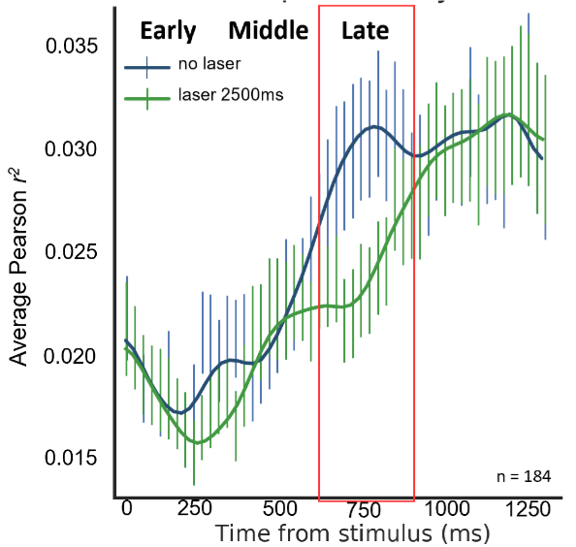

**Figure 1**—unilaterally perturbing activity in LH◊GC axons hinders the emergence of palatability-related firing in GC. Note the delay in the rise of the correlation of firing with palatability (y-axis) at the beginning of the Late (palatability coding) epoch. This result, which becomes much stronger with bilateral perturbation (data not shown), is reminiscent of that shown for perturbation of BLA◊GC projections (see Ref. #12). *Preliminary data*.

Research Strategy Page 34

Contact PD/PI: Katz, Donald B

*Approach*

The experiments for Aim 1 of this supplement will make use of the same techniques described in the parent grant, here used to assess GC-PC interactions during tasting. This includes (as described above) the implantation of drivable electrode bundles that will enable Thomas to record neuronal activity simultaneously from GC and PC, as well as an IOC to deliver intraoral stimuli. Following recovery from implantation surgery, rats will be habituated to the recording arena and water deprived to encourage acceptance and consumption of liquids delivered through the IOC. Recordings of spontaneous activity before and after taste deliveries will provide a basic measure of baseline coherence/coupling between GC and PC, which will then be compared to GC-PC coherence during the processing of tasty fluids delivered—with or without odiferous components—to the rat over a period of 60 minutes. Thomas will test the extent to which inter- regional coherence is dependent on the delivery and type of stimulus; his preliminary results (**Figure 2**) suggest that the two regions interact during taste processing, and that this coupling is stronger during processing of “flavors” (odor-taste pairs). Additional experiments (also identical in form to those described in the parent grant) will involve surgeries in which Thomas infects PC projections to GC with virus coding for ArchT (and GFP) so that he can perturb PC◊GC fibers (as they enter GC) during stimulus processing; this experiment will allow him to test whether direct PC input impacts GC coding of taste and flavor stimuli.

The approach for Aim 2 will employ similar methods to those used for Aim 1, with a focus on  
interactions between GC and PC involved in processing odor stimuli. These experiments will require precise measurements of breathing (so that Thomas can know when odor molecules are being passed across the nasal epithelium), which will be achieved through implantation of a nasal cannula in the nasal cavity of the rat. Alignment of breathing with IOC deliveries of odors dissolved in water will be important for identifying the relationship of GC and PC activation to odor delivery. The experiments, and hypotheses tested, will thereafter proceed analogously to those described for Aim 1—Thomas will test whether GC is coupled with PC for purposes of odor processing, and whether perturbation of activity in GC◊PC axons interferes with PC odor coding.